**What is Collision?**

Since a hash function gets us a small number for a key which is a big integer or string, there is a possibility that two keys result in the same value. The situation where a newly inserted key maps to an already occupied slot in the hash table is called collision and must be handled using some collision handling technique.

**What are the chances of collisions with large table?**

Collisions are very likely even if we have big table to store keys. An important observation is [Birthday Paradox](https://www.geeksforgeeks.org/birthday-paradox/). With only 23 persons, the probability that two people have the same birthday is 50%.

**How to handle Collisions?**   
There are mainly two methods to handle collision:   
1) Separate Chaining   
2) Open Addressing 

1. **Separate Chaining:**   
   The idea is to make each cell of hash table point to a linked list of records that have same hash function value.

Let us consider a simple hash function as “**key mod 7**” and sequence of as 50, 700, 76, 85, 92, 73, 101.

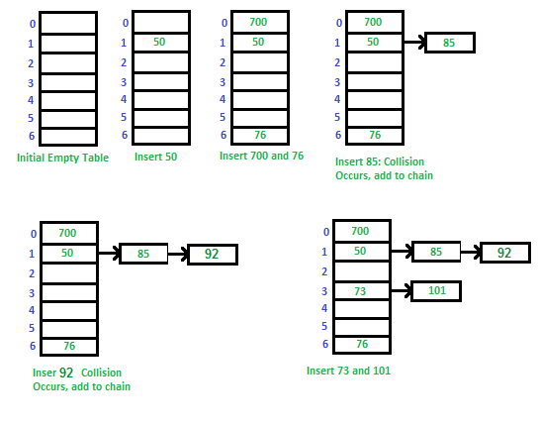

**Advantages:**   
1) Simple to implement.   
2) Hash table never fills up, we can always add more elements to the chain.   
3) Less sensitive to the hash function or load factors.   
4) It is mostly used when it is unknown how many and how frequently keys may be inserted or deleted.

**Disadvantages:**   
1) Cache performance of chaining is not good as keys are stored using a linked list. Open addressing provides better cache performance as everything is stored in the same table.   
2) Wastage of Space (Some Parts of hash table are never used)   
3) If the chain becomes long, then search time can become O(n) in the worst case.   
4) Uses extra space for links.

**Performance of Chaining:**   
Performance of hashing can be evaluated under the assumption that each key is equally likely to be hashed to any slot of table (simple uniform hashing).

|  |
| --- |
| m = Number of slots in hash table  n = Number of keys to be inserted in hash table    Load factor α = n/m    Expected time to search = O(1 + α)    Expected time to delete = O(1 + α)  Time to insert = O(1)  Time complexity of search insert and delete is  O(1) if α is O(1) |

**Data Structures for Storing Chains:**

* Linked lists
  + Search: O(l) where l = length of linked list
  + Delete: O(l)
  + Insert: O(l)
  + Not cache friendly
* Dynamic Sized Arrays (Vectors in C++, ArrayList in Java, list in Python)
  + Search: O(l) where l = length of array
  + Delete: O(l)
  + Insert: O(l)
  + Cache friendly
* Self-Balancing BST (AVL Trees, Red Black Trees)
  + Search: O(log(l))
  + Delete: O(log(l))
  + Insert: O(l)
  + Not cache friendly
  + Java 8 onwards use this for HashMap

1. **Open Addressing**   
   Like separate chaining, open addressing is a method for handling collisions. In Open Addressing, all elements are stored in the hash table itself. So at any point, the size of the table must be greater than or equal to the total number of keys (Note that we can increase table size by copying old data if needed).

**Insert(k):** Keep probing until an empty slot is found. Once an empty slot is found, insert k.

**Search(k):** Keep probing until slot’s key doesn’t become equal to k or an empty slot is reached.

**Delete(k):** ***Delete operation is interesting***. If we simply delete a key, then the search may fail. So slots of deleted keys are marked specially as “deleted”.   
The insert can insert an item in a deleted slot, but the search doesn’t stop at a deleted slot.

Open Addressing is done in the following ways:

***a) Linear Probing:*** In linear probing, we linearly probe for next slot. For example, the typical gap between two probes is 1 as seen in the example below.   
Let **hash(x)** be the slot index computed using a hash function and **S** be the table size

|  |
| --- |
| If slot hash(x) % S is full, then we try (hash(x) + 1) % S  If (hash(x) + 1) % S is also full, then we try (hash(x) + 2) % S  If (hash(x) + 2) % S is also full, then we try (hash(x) + 3) % S  ..................................................  .................................................. |

Let us consider a simple hash function as “key mod 7” and a sequence of keys as 50, 700, 76, 85, 92, 73, 101.

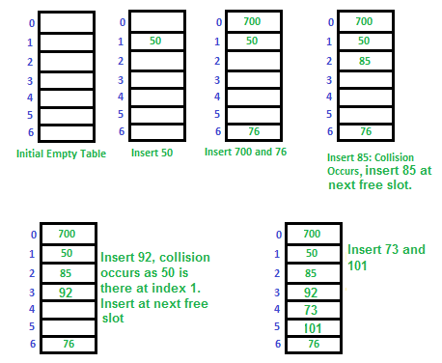

**Challenges in Linear Probing :**

1. **Primary Clustering:** One of the problems with linear probing is Primary clustering, many consecutive elements form groups and it starts taking time to find a free slot or to search for an element.
2. **Secondary Clustering*:***Secondary clustering is less severe, two records only have the same collision chain (Probe Sequence) if their initial position is the same.

***b) Quadratic Probing*** We look for i2‘th slot in i’th iteration.

|  |
| --- |
| let hash(x) be the slot index computed using hash function.  If slot hash(x) % S is full, then we try (hash(x) + 1*1) % S  If (hash(x) + 1*1) % S is also full, then we try (hash(x) + 2*2) % S  If (hash(x) + 2*2) % S is also full, then we try (hash(x) + 3*3) % S  ..................................................  .................................................. |

**c) Double Hashing** We use another hash function hash2(x) and look for i*hash2(x) slot in i’th rotation.

|  |
| --- |
| let hash(x) be the slot index computed using hash function.  If slot hash(x) % S is full, then we try (hash(x) + 1*hash2(x)) % S  If (hash(x) + 1*hash2(x)) % S is also full, then we try (hash(x) + 2*hash2(x)) % S  If (hash(x) + 2*hash2(x)) % S is also full, then we try (hash(x) + 3*hash2(x)) % S  ..................................................  .................................................. |

**Comparison of above three:**   
Linear probing has the best cache performance but suffers from clustering. One more advantage of Linear probing is easy to compute.   
Quadratic probing lies between the two in terms of cache performance and clustering.   
Double hashing has poor cache performance but no clustering. Double hashing requires more computation time as two hash functions need to be computed.

|  |  |  |
| --- | --- | --- |
| S.No. | Separate Chaining | Open Addressing |
| 1. | Chaining is Simpler to implement. | Open Addressing requires more computation. |
| 2. | In chaining, Hash table never fills up, we can always add more elements to chain. | In open addressing, table may become full. |
| 3. | Chaining is Less sensitive to the hash function or load factors. | Open addressing requires extra care to avoid clustering and load factor. |
| 4. | Chaining is mostly used when it is unknown how many and how frequently keys may be inserted or deleted. | Open addressing is used when the frequency and number of keys is known. |
| 5. | Cache performance of chaining is not good as keys are stored using linked list. | Open addressing provides better cache performance as everything is stored in the same table. |
| 6. | Wastage of Space (Some Parts of hash table in chaining are never used). | In Open addressing, a slot can be used even if an input doesn’t map to it. |
| 7. | Chaining uses extra space for links. | No links in Open addressing |

**Performance of Open Addressing:**   
Like Chaining, the performance of hashing can be evaluated under the assumption that each key is equally likely to be hashed to any slot of the table (simple uniform hashing)

|  |
| --- |
| m = Number of slots in the hash table  n = Number of keys to be inserted in the hash table  Load factor α = n/m ( < 1 )  Expected time to search/insert/delete < 1/(1 - α)  So Search, Insert and Delete take (1/(1 - α)) time |